Stats Library Documentation
Overview
The StatsLibrary class is designed to provide a set of methods for calculating various statistical distributions and probabilities. It includes functionalities for computing factorial, Poisson probability, Chebyshev's inequality, uniform distribution PDF, and normal distribution PDF. This library is useful for statistical analysis and probability calculations in Java applications.

Factorial
The factorial method calculates the factorial of a given number. It returns the factorial result as a double, or 0 if the input is negative. For example, calling factorial(5) will return 120.0.
public double factorial(int num) {
if (num < 0) return 0; // Return 0 if input is negative
if (num == 0 || num == 1) return 1; // Return 1 if input is 0 or 1
double result = 1; // Initialize result to 1
for (int i = 2; i <= num; i++) { // Loop from 2 to num
result *= i; // Multiply result by i
}
return result; // Return the factorial result
}

Poisson Probability
The calculatePoisson method computes the Poisson probability for a given average rate of success and number of occurrences. For instance, calling calculatePoisson(2.0, 3) will return approximately 0.1804.
*
* @param lambda The average rate of success
* @param y The number of occurrences
* @return The Poisson probability
*/
public double calculatePoisson(double lambda, int y) {
return (Math.pow(lambda, y) * Math.exp(-lambda)) / factorial(y); // Calculate Poisson probability
}

Chebyshev's Inequality
The calculateChevyshevs method calculates Chebyshev's inequality for a given number of standard deviations. For example, calling calculateChevyshevs(2.0) will return 0.75.
/**
* Calculates Chebyshev's inequality
*
* @param k The number of standard deviations
* @return The probability according to Chebyshev's inequality
*/
public double calculateChevyshevs(double k) {
return (1 - (1 / Math.pow(k, 2))); // Calculate Chebyshev's inequality
}

Uniform Distribution PDF
The uniformDistribution method calculates the uniform distribution PDF for a given value and bounds. For example, calling uniformDistribution(0.5, 0, 1) will return 1.0.
* Calculates the uniform distribution PDF
*
* @param x The value at which to evaluate the PDF
* @param a The lower bound of the uniform distribution
* @param b The upper bound of the uniform distribution
* @return The PDF value at x
*/
public static double uniformDistribution(double x, double a, double b) {
if (a >= b) {
throw new IllegalArgumentException("Lower bound a must be less than upper bound b"); // Validate bounds
}
if (x >= a && x <= b) {
System.out.println("Expected value:"+ (b=a)/2);
System.out.println("Variance:"+ Math.pow(b-a,2)/2);

return 1.0 / (b - a); // Return PDF value if x is within bounds

} else {
return 0.0; // Return 0 if x is outside bounds
}

Normal Distribution PDF
The normalDistribution method calculates the normal distribution PDF for a given value, mean, and standard deviation. For example, calling normalDistribution(0, 0, 1) will return approximately 0.3989.
/**
* Calculates the normal distribution PDF
*
* @param x The value at which to evaluate the PDF
* @param mu The mean of the normal distribution
* @param sigma The standard deviation of the normal distribution
* @return The PDF value at x
*/
public static double normalDistribution(double x, double mu, double sigma) {
if (sigma <= 0) {
throw new IllegalArgumentException("Standard deviation must be positive"); // Validate sigma
}
double exponent = -Math.pow(x - mu, 2) / (2 * Math.pow(sigma, 2)); // Calculate exponent
return (1.0 / (sigma * Math.sqrt(2 * Math.PI))) * Math.exp(exponent); // Return normal PDF value
}
TESTER CODE
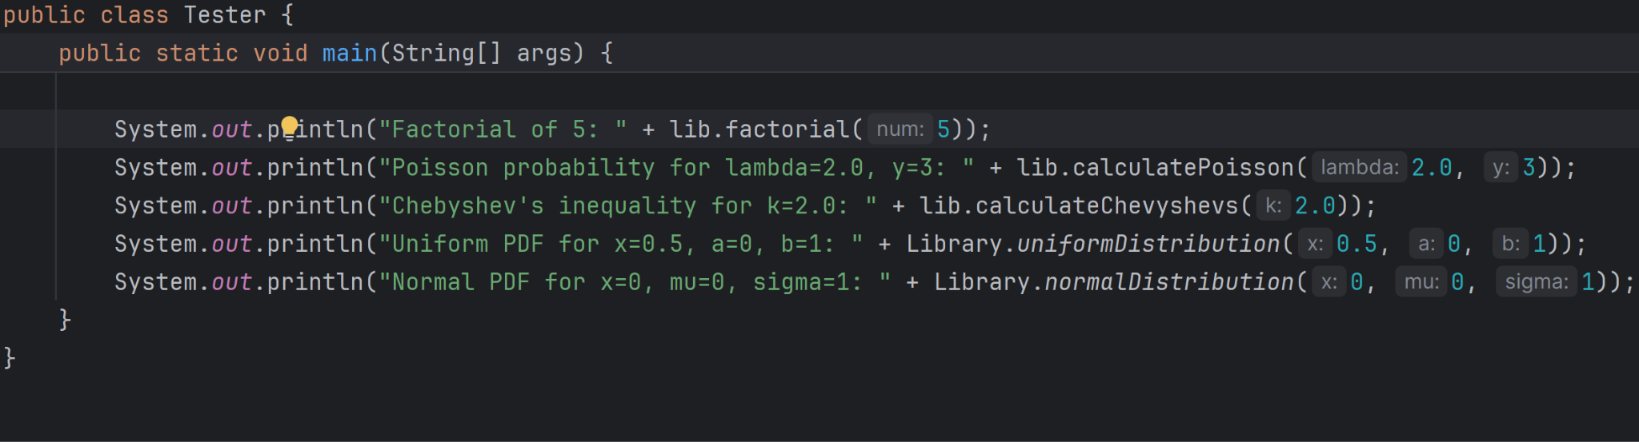
Output
